MC900020667[1]MC900020667[1]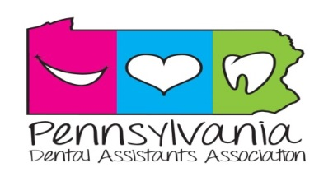

**Fall 2019 newsletter**

**NEWSLETTER**

WHAT’S HAPPENING

The Pennsylvania Dental Assistants Association (PDAA) would like to invite you to join us for our Fall General Assembly Meeting on Friday, November 15 and Saturday, November 16, 2019. This 2 day event will include the opportunity to earn up to 10 CE credits, join other dental assistants for a time of fun, prizes and great food, and attend the Fall General Assembly meeting where you can see firsthand how your State Association operates.

COMMUNITY SERVICE PROJECT

PDAA will be sponsoring a Community Service Food Drive for the Central Pennsylvania Food Bank. Bring your nonperishable food items and help make someone’s Thanksgiving meal a little brighter. Cash donations will also be accepted.

BECOME A MEMBER

Now is the perfect time to become a member of the American Dental Assistants Association (ADAA). As a member you can save up to $50 off of your registration fees for the upcoming PDAA Fall General Assembly Meeting. Benefits include over 100 free online continuing education courses and professional liability (malpractice) insurance just to name a few, application with a full benefit list can be found at adaausa.org. JOIN TODAY and see all that ADAA has to offer.

THANK YOU TO OUR SPONSORS

A special thank you to our corporate sponsors including Kavo Kerr, PureLife, Premier Dental, Toothsmiths Dental Laboratory, and Buehler Family Dental.