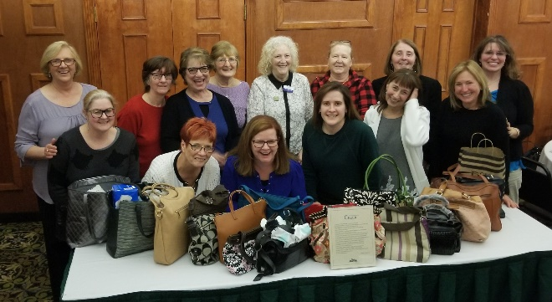I know we have men in our midst, so I challenge them to come forth! Join us Our group in Wilkes Barre were all ladies, with the exception of a dentist who braved our gathering We had a lovely time.

Spring PDAA Meeting!
What a blast! Great people, great speakers… I just have to say, “What a fantastic group of women!”
Lancaster County Dental Assistant Society
We went over handpieces: both (electric and pneumatic) and lubing with Dan . Being aware of having the correct handpiece for the job. Not just slow or high, but there are brand considerations, psi, motors…my brain was spinning! How much, as an assistant, do you pay attention to the handpieces? That’s always the dentist’s toys right? Well, having a hold on knowing if the handpiece needs oil, or no oil, too much psi, why are we burning through motors or transmissions…and you would know simply by reading the instructions. Blow me down! The cool thing about Handpieces is that honestly you cannot over oil them. You can’t! However, it is the not purging the excess oil that is

detrimental to the handpiece. Also, you need to lube the chucks at least once a week without the bur in, and purge with the bur in. Always, always read the directions for your handpiece. There will be differences per brand, per model…so always be aware of the particulars. Note: if you have a non-oil model, BUT YOU HAVE OILED IT you now have to continue oiling!
Quiz: Any idea how many handpieces you should have per operatory?
This field is amazing simply for the sheer volume of knowledge and change! We have to stay on our toes!

We had Dr. Fred Lally MAGD with an information course on opioids and medical emergencies. If you are an office that dispences narcotics, there is so much to keep up on! The prescription drug database that is used to track patients who may be abusers is definitely comprehensive and worth the expense. It is overseen by the Attorney General and available in 49 states (excluding Missouri) and California was the first in 1939. There are 20 states that can be checked at one time. The database is used to see if the patient has one or more prescriptions under their name already. The database is just a screen, to help pool from other doctors. Be aware of your patients. Ask questions, check health histories, be weary of the late night/ weekend patient, the pushy one asking for prescriptions, the one whose pet seems to eat a lot of their medications or the one clumsy one who seems to knock them into the toilet… all true. Happened to our speaker
Then we had Julie and Val with radiology. Just as everything else is advancing, so to is radiology. Digital, with the hand held Nomads (and other brands) come with a whole new set of rules. Same infection control procedures and standards, but making sure you, the operator, are protected that is the key. The concept of ALARA (As Low As Reasonably Acheivable) is the key at all times. Having a protocol in place, as well.
- Bisecting in reverse (holding Nomad adjusting with tubehead)
- PA cutoff? Remedy that!
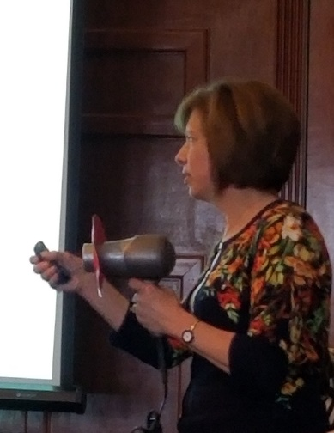
Julie’s Nomad!
- Shield in place to protect you NOT the patient!
- How are you holding the Nomad to protect yourself?
We thoroughly enjoyed all of our speakers and Lancaster is reaching out to make sure we can entice them to our fair county
If you see our picture at the beginning, those are your representatives for your state! In front of the ladies is the community project that we were a part of. We were asked to bring in gently used purses, filled with goodies to donate to the (Woman’s House in Wilkes Barre) to help bring a smile to a face. Look at that collection! I am sure we brought some smiles!
Please keep that in mind: at each event we do a community service project. If you have any ideas for one, or one that is close to your heart, contact us!

Remember: September 21, 2019

Answers: 3-4: 1-in use, 1 in auto clave, 1 cooling NATURALLY

