For Dental Assistant Recognition Week, we held a meeting up at the Lebanon County Career & Technology Center. It was a way to integrate our members with our next generation of dental assistants while showing everyone appreciation with the facilities on campus: the wonderful Hilltop Café and the aspiring students of the cosmetology department.

Today’s dental assistants strengthen the entire practice and enhance patient satisfaction around the world. Dental assistants are committed to professional development and quality dental care.
-ADAA
Lancaster County Dental Assistant Society
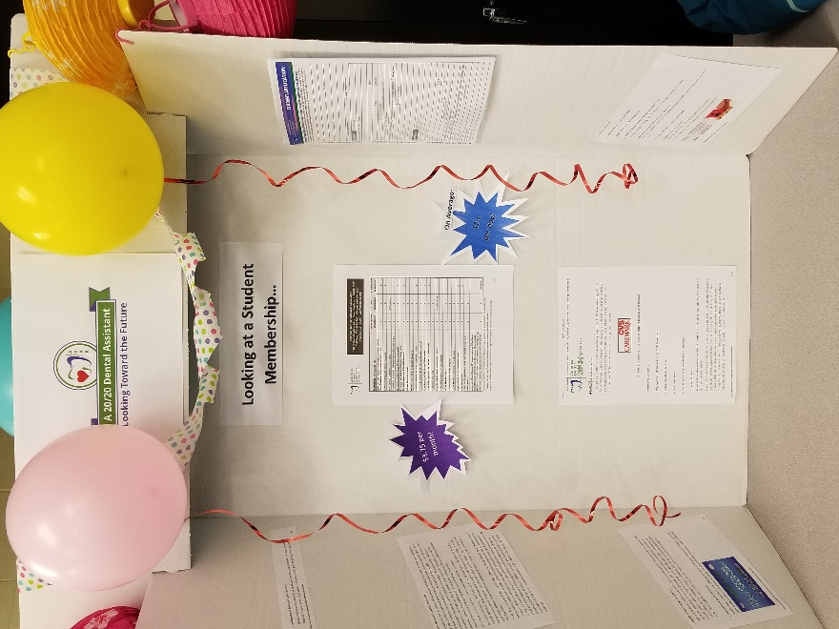

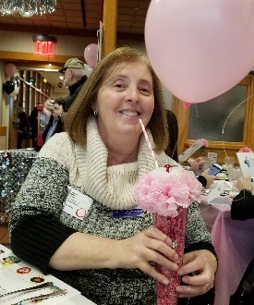
Our ADAA president, Robynn Rixse was in attendence for our meeting and lunch.
Originally I was going to
present on appreciation and
office interactions, however,
with recent events being what
they are, I went a different way.
The title of the presentation
was, “Is This A Pandemic? How
Will the Coronavirus Affect the Dental Office?” We went over our standard precautions, the differences between the coronavirus (COVID-19 and why it is called that), flu and how we will see impacts or are already seeing impacts from this.
The students were receptive, asked interesting questions and were engaged in discussion. Showing great thoughts about our standard precautions and should anything happen in our area, they were quick to say the correct answer regarding how they should react in situations should events transpire here. Before we went to lunch, I asked our ADAA president to present an impromptu presentation about the student membership and why it’s important to be a member because I know that is a passion for her. Not that she needed any help but I put together the visual aid (left) and the students decorated it for me.
It was a serious subject that we followed up with some fun at the Hilltop Café for lunch, which was decorated for their 1950’s week

.
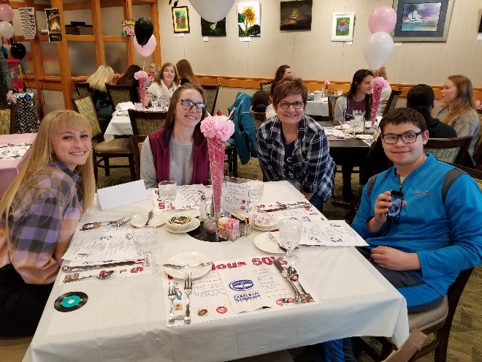
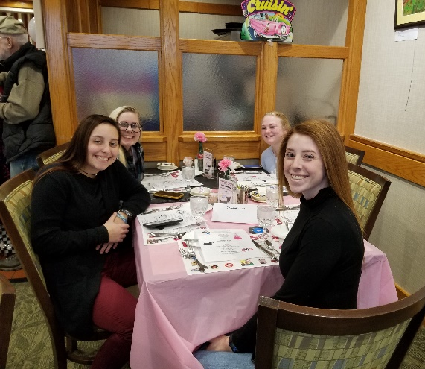
There were burgers and milkshakes and poodle skirts, with Grease playing in the background and the Big Bopper Singing, it was like stepping back in time! Fun history facts from the 1950’s were on the tables as well. When Chef Corle and Chef Peffley put something together you can be sure it will be done right! After we had lunch, we visited the Cosmetology class which is run by Mrs. Spandel and Mrs. Werni. Their class showered us with appreciation in either manicures, shampoos, braiding or waxing (eyebrows)… and well, it is just so much more fun to show you!

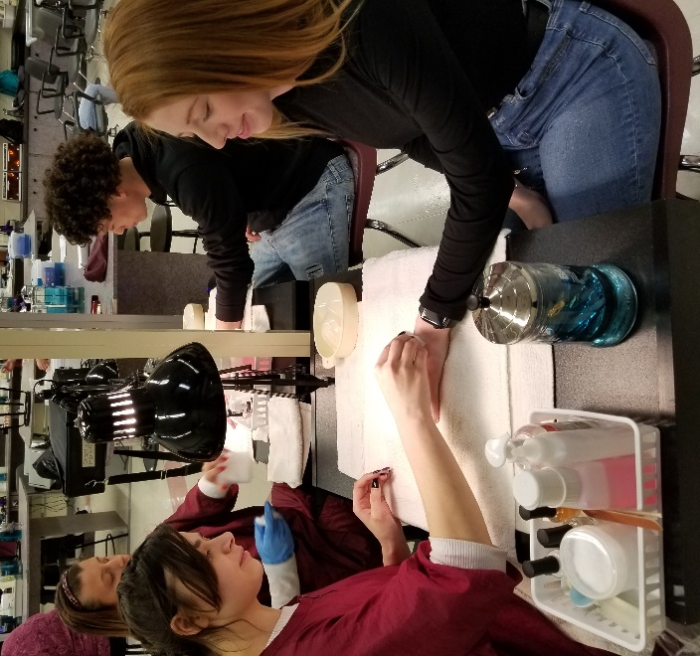

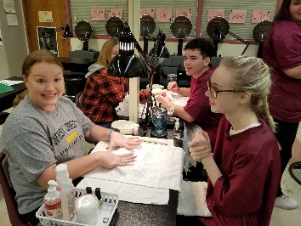
BeforeWax After Wax

